Harrow Bay O&M Readiness Plan
From first power 2027 to COD 2028
David Chen · 27 August 2026 · HB-OPS-PLN-0001

1. Purpose
This plan describes how Asset Operations will be ready to operate Harrow Bay Offshore Wind (480 MW, 40 × Halden HTS-12 (12 MW), rotor diameter 236 m, hub height 140 m) from first power (planned 30 September 2027) and to take full responsibility at the commercial operation date (planned 30 June 2028). It is owned by David Chen and agreed with Elena Márquez as Project Director.

2. Operating model
Area | During warranty (COD – COD+5) | After warranty
Turbines (40 × HTS-12) | Halden Turbine Systems – warranty-period service under the turbine supply agreement (WE-CON-2025-022) | Option: long-term service agreement or ISP
Balance of plant (OSS, cables, foundations) | Weyland O&M team + specialist contractors | Same
Marine coordination | Weyland marine coordination centre at Port of Eastholm | Same
Vessels | 3 crew transfer vessels (CTV) on long-term charter; SOV decision in 2027 | Review
Remote operation | Weyland Control Centre, Edinburgh (24/7) | Same
Grid compliance | Weyland with NordGrid Transmission | Same

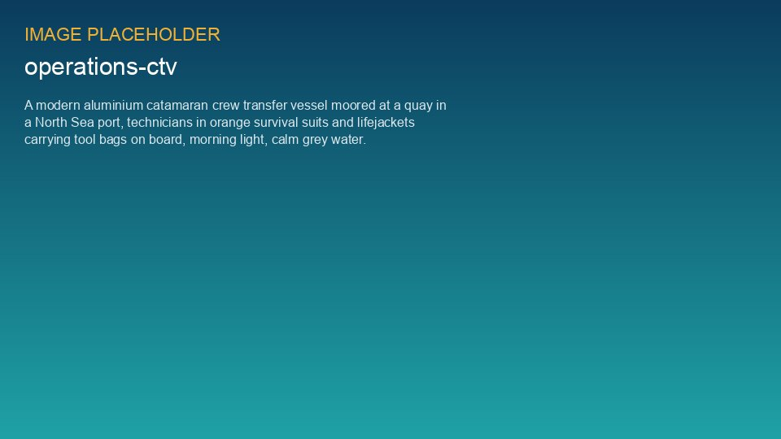
Crew transfer vessels will operate from the O&M base at Port of Eastholm

3. Readiness workstreams
# | Workstream | Lead | Key deliverable | Due
1 | O&M base at Port of Eastholm | Ben Okoye | Lease signed, building fit-out, pontoon | Lease Q1 2027, ready Q3 2027
2 | Organisation and recruitment | Julia Hoffmann / David Chen | 32 FTE recruited and trained | Ramp-up Q2 2027 – Q2 2028
3 | Vessels and marine coordination | Ingrid Solberg | CTV charter contracts, marine coordination procedures | Q2 2027
4 | Control room integration | Sara Lindgren / Katarzyna Nowak | SCADA link, alarm matrix, operator training | Q3 2027
5 | Spare parts and warehouse | Patrick Doyle | Capital spares list (incl. spare export cable section, transformer bushings) | Q4 2027
6 | HSE and emergency response | Hannah Weber / Yusuf Demir | Offshore ERP for operations, GWO training, helicopter assessment | Q2 2027
7 | Contracts | Priya Nair | BoP maintenance, cable repair framework, vessel charters | Q2 2027
8 | Handover from project | Elena Márquez / Felix Brandt | Handover dossier per system, punch lists, as-built documentation | rolling from first power

4. Staffing ramp-up
The O&M organisation grows from 4 FTE in 2026 (planning team) to 32 FTE at COD. Recruitment of offshore technicians starts in April 2027 so that the first team can shadow Halden during commissioning of the first turbines.
Role | Q4 2026 | Q2 2027 | Q4 2027 | Q2 2028 (COD)
Site / O&M manager | 1 | 1 | 1 | 1
Marine coordinators | 0 | 2 | 4 | 5
BoP / HV technicians | 0 | 2 | 6 | 10
Control room operators (additional) | 0 | 0 | 2 | 4
Planning, performance, admin | 3 | 4 | 6 | 7
HSE advisors | 0 | 1 | 2 | 2
Warehouse / logistics | 0 | 0 | 2 | 3
Total | 4 | 10 | 23 | 32

5. Budget
The steady-state operating budget for Harrow Bay is estimated at EUR 41 m per year (2028 prices), of which turbine service is about 45 %, vessels 18 %, BoP maintenance 9 %, staff 8 %, insurance 12 % and other costs 8 %. Pre-COD readiness costs of EUR 6.8 m are included in the project budget.

6. Interfaces with the construction schedule
- First turbine installation is planned for 1 March 2027 and first power for 30 September 2027; the O&M base must be usable by then.
- HB-RISK-017 (8-week delay of export cable 2) may shift the energisation sequence. Readiness planning assumes energisation via export cable 1 first; no change to the O&M base dates is needed.
- Lessons from Kestrel Ridge (T-07 gearbox) are built into the HTS-12 CMS set-up: Weyland-owned thresholds and data access from day one are a requirement in the handover criteria.

7. Key risks

